Calc-141230 Rev A

Choice of 6cm Diameter

Purpose: Inform the choice of diameter of the proposed portable faraday cup by simulating signal error vs diameter. Note that the cylinder height of 10cm was chosen based simplistically on the range of 250 MeV protons.

Method:

MCNP version 6.1 with standard cross-section libraries was used to simulate gain. The material geometry is shown in Figure A. The height of the cylinder is fixed at 10 cm. The diameter is varied from 2 to 10 cm and the kapton thickness is varied from 25 to 75 microns. The materials are standard copper, kapton, silver and air and STP. The source is a 2cm diameter proton beam at 250 MeV. This is the maximum expected energy. A suitable diameter for this energy will be suitable for lower energies. Physics was turned on for seven particles: neutrons, photons, electrons, protons, deuterons, tritons and alphas.

Gain was modeled simplistically by tallies of two charged particles (protons and electrons) crossing three surfaces (face, side and end). Gain is expressed in terms of elemental charge deposited in copper per beam proton. The equation is

Gain = proton_in – proton_out – electron_in + electron_out

MCNP6 distinguished between two types of secondary electrons, those that are created by proton collisions, i.e., SE_h, (MCNP cannot track such electrons) and those that are generated by other particles (notably photons that are themselves secondary), i.e., SE_!h. It was assumed that for the selection of a good copper diameter the SE_h are not important. This assumption was not tested.

It is assumed that protons and electrons are the only contributors to gain. This was tested (for SE_!h only) and found to be true within a factor of 2E-4.

It was also assumed that the detailed behavior of SE_!h electrons in Kapton (i.e., capture causing mirror charge in copper) has little effect on the choice of copper diameter. This means that the location and energy of electrons captured in the kapton do not have to be tallied to get a good answer for the copper diameter. This assumption was not tested.

The detector is to be a beam proton counter. The perfect detector will yield a gain of unity, i.e., 1 exactly. The equation for error is thus

Error (percent) = 100 x (Gain -1)

Results:

Figure D shows the variation of error with copper diameter and method. Two methods are compared, SRIM (reference) and MCNP6. A diameter of 6cm seems reasonable.

The same calculation was repeated with proton tallies alone, i.e., without any secondary electrons. This shows that if electrons had been completely ignored, the MCNP6 results would have been similar to the SRIM model and a diameter of 8cm would have seemed reasonable.

The distribution of proton collisions from 50 beam protons is in Figure B. The distribution of 6 other particles (born of 50 Protons) is in Figure C. Neutrons go everywhere. The distribution of electrons (just type SE_!h) is similar to photons. Table A shows the boundary crossings of neutral particles. In the problem there are about two neutral particle boundary crossings per beam proton.

Table B shows the breakdown of gain from various charged particles for given directions and copper surfaces. This assumes 250 MeV Proton Beam, 6cm Copper Diameter and 50 microns kapton. The effect of secondary electrons produced directly by proton collisions (SD_h) is not included.

It is worth examining the behavior of the model. Kapton thickness (25, 50 and 75 microns) seems to make no difference in gain. Neither do the inclusion of tallies for deuterons, tritons and alphas, although the MCNP output file notes the absence of production cross-sections for these particles[1].

All of the figures and tables below were for the case of 6cm diameter, 50 microns of kapton and 50 beam protons of energy 250 MeV.

Discussion:

1. It is known that mcnp does not track electrons secondary to protons. Therefore, there are delta rays and secondary electrons from protons that have not been accounted for. This means that the error is greater than has been portrayed. This needs further investigation because it is shown in Figure D that electrons (just the SE_!h) have an impact on the choice of diameter.

2. The electrons that are included are those that are secondary to the particle cascade subsequent to protons. For example, there are electrons secondary to photons that come from neutrons that come from protons. The table below shows that there are almost 2 neutral particles crossing the fc boundary per beam proton.

3. The addition of deuterons, tritons and alphas changes the gain by -0.0002[2].

4. There were no proton creation cross-sections for Ag-107, there were for Ag-109 which makes up about 2/3 of the silver.

Table A – Neutral Particle Crossings per Beam Proton

|  |  |  |  |  |  |
| --- | --- | --- | --- | --- | --- |
| neutral particles crossing copper surfaces (fraction per source proton) | | | | | |
|  |  | face | cylinder | far end | total |
| Neutrons | in | 0.00065 | 0.00044 | 0.10692 | 0.10801 |
|  | out | 0.14874 | 0.67867 | 0.00007 | 0.82747 |
| Photons | in | 0.00038 | 0.00070 | 0.00011 | 0.00119 |
|  | out | 0.17603 | 0.65051 | 0.07812 | 0.90466 |

Table B – charges crossing copper surfaces (fraction per source proton) assuming 250 MeV Proton Beam, 6cm Copper Diameter and 50 microns kapton. No SD_h.

|  |  |  |  |  |  |
| --- | --- | --- | --- | --- | --- |
|  |  | face | cylinder | end | total |
| P+ | in | 0.99997 | 0.00000 | 0.00000 | 0.99997 |
| out | -0.00055 | -0.00123 | -0.00023 | -0.00201 |
| total | 0.99941 | -0.00123 | -0.00023 | 0.99796 |
| E  Without SE_h | in | -0.00031 | -0.00087 | -0.00010 | -0.00128 |
| out | 0.00149 | 0.00450 | 0.00051 | 0.00650 |
| total | 0.00119 | 0.00362 | 0.00042 | 0.00523 |
| d | in | 0.00003 | 0.00000 | 0.00000 | 0.00003 |
| out | -0.00007 | -0.00006 | -0.00002 | -0.00015 |
| total | -0.00004 | -0.00006 | -0.00002 | -0.00012 |
| t | in | 0.00002 | 0.00000 | 0.00000 | 0.00002 |
| out | -0.00002 | 0.00000 | 0.00000 | -0.00003 |
| total | -0.00001 | 0.00000 | 0.00000 | -0.00001 |
| a | in | 0.00003 | 0.00000 | 0.00000 | 0.00003 |
| out | -0.00003 | 0.00000 | 0.00000 | -0.00003 |
| total | 0.00000 | 0.00000 | 0.00000 | 0.00000 |
| Signal | in | 0.99974 | -0.00087 | -0.00010 | 1.00124 |
| out | 0.00082 | 0.00320 | 0.00026 | -0.00851 |
| total | 0.99823 | -0.00485 | -0.00065 | 0.99273 |

Figure D – Signal Error vs Diameter and Method

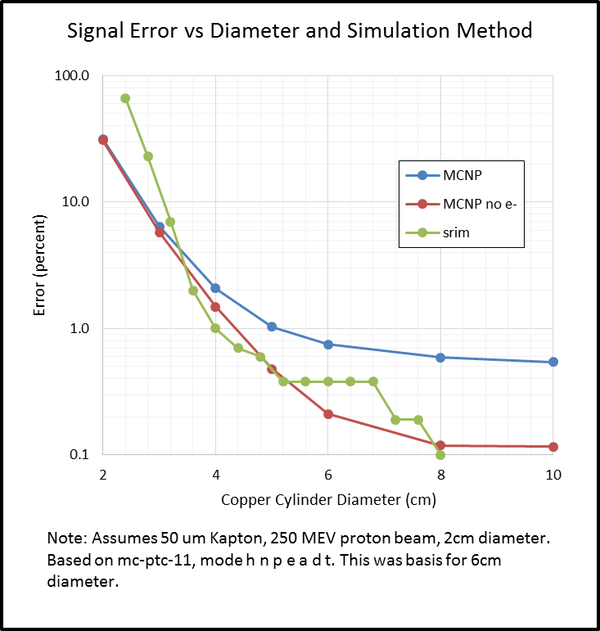

Figure A – Geometry from side of horizontal copper cylinder.

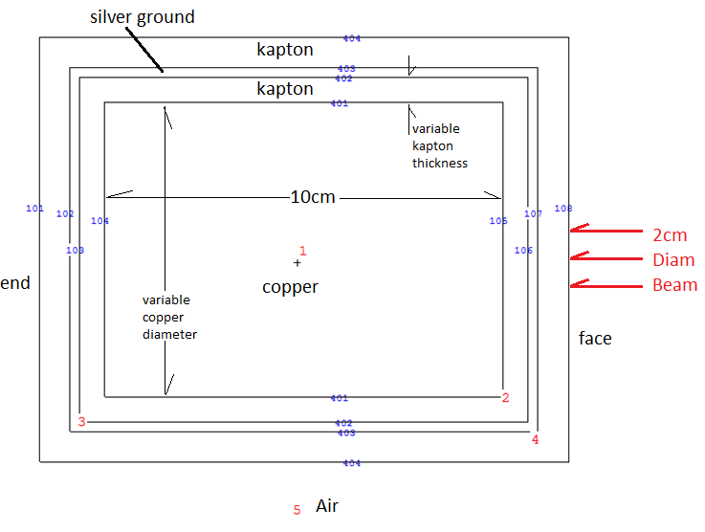

Figure B – Distribution of 50 Protons of Energy 250 MEV (note one backscatter)

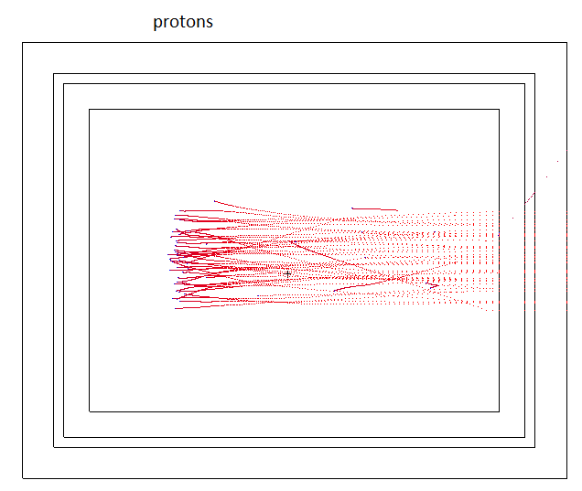

Figure C – Distribution of Six other particles

|  |  |
| --- | --- |
|  |  |
|  |  |
|  |  |

1. The absence of ion production XS noted in the MCNP output file vs the presence of ions in the run needs to be checked out.
2. See mc-ptc-11-3.0-f for effect of d t a.